Data base technology practical

Employee table contains the information of employee_id, first_name, last_name, email, phone number, hire_date, job_id, salary, comission_pct, manager_id, department_id. create the table and insert the value inside the table. Show the structure of the Employee table. Create a Query to display the last name, job code, hire date, and employee number for each employee. de, hire date, and employee number for each employee.

SQL is a language that allows you to create, manipulate, and query data stored in relational databases. A table is a collection of related data organized into rows and columns. To create a table, you need to specify its name, columns, and data types. To insert values into a table, you need to provide the column names and the values for each row.

For example, if you want to create a table named employee with the information you mentioned, you can use the following SQL statement:

CREATE TABLE employee (

employee_id INT PRIMARY KEY,

first_name VARCHAR(50),

last_name VARCHAR(50),

email VARCHAR(100),

phone_number VARCHAR(20),

hire_date DATE,

job_id VARCHAR(10),

salary DECIMAL(10,2),

commission_pct DECIMAL(4,2),

manager_id INT,

department_id INT

);

Copy

This statement creates a table named employee with 11 columns. Each column has a name and a data type. The employee_id column is also defined as the primary key, which means it uniquely identifies each row in the table. You can also specify other constraints, such as NOT NULL, UNIQUE, or FOREIGN KEY, to enforce data integrity rules.

To insert values into the employee table, you can use the following SQL statement:

INSERT INTO employee (

employee_id,

first_name,

last_name,

email,

phone_number,

hire_date,

job_id,

salary,

commission_pct,

manager_id,

department_id

)

VALUES (

100,

'Steven',

'King',

'steven.king@company.com',

'515.123.4567',

'2003-06-17',

'AD_PRES',

24000.00,

NULL,

NULL,

90

);

Copy

This statement inserts a new row into the employee table with the values provided for each column. You can also insert multiple rows at once by using multiple sets of values separated by commas. For example:

INSERT INTO employee (

employee_id,

first_name,

last_name,

email,

phone_number,

hire_date,

job_id,

salary,

commission_pct,

manager_id,

department_id

)

VALUES

(

-- First row

...

),

(

-- Second row

...

),

(

-- Third row

...

);

Copy

To show the structure of a table in SQL, you can use different commands depending on the database system you are using. For example, in SQL Server, you can use sp_help or sp_columns to display information about a table and its columns. In Oracle or MySQL, you can use DESCRIBE or DESC to do the same. You can also query the INFORMATION_SCHEMA.COLUMNS view to get metadata about the columns of a table in any database that supports it.

For example, if you want to show the structure of the employee table in SQL Server, you can use either of these commands:

sp_help employee;

sp_columns employee;

Copy

If you want to show the structure of the employee table in Oracle or MySQL, you can use this command:

DESCRIBE employee;

Copy

If you want to show the structure of the employee table using the INFORMATION_SCHEMA.COLUMNS view, you can use this query:

SELECT *

FROM INFORMATION_SCHEMA.COLUMNS

WHERE TABLE_NAME = 'employee';

Copy

To display the last name, job code, hire date, and employee number for each employee in SQL, you can use a simple SELECT statement to query the employee table. You can also use an alias for the hire_date column to make it more descriptive.

For example, you can use this SQL statement:

SELECT last_name, job_id, hire_date AS startdate, employee_id

FROM employee;

Copy

This statement selects four columns from the employee table and renames the hire_date column as startdate. It returns all rows from the table.

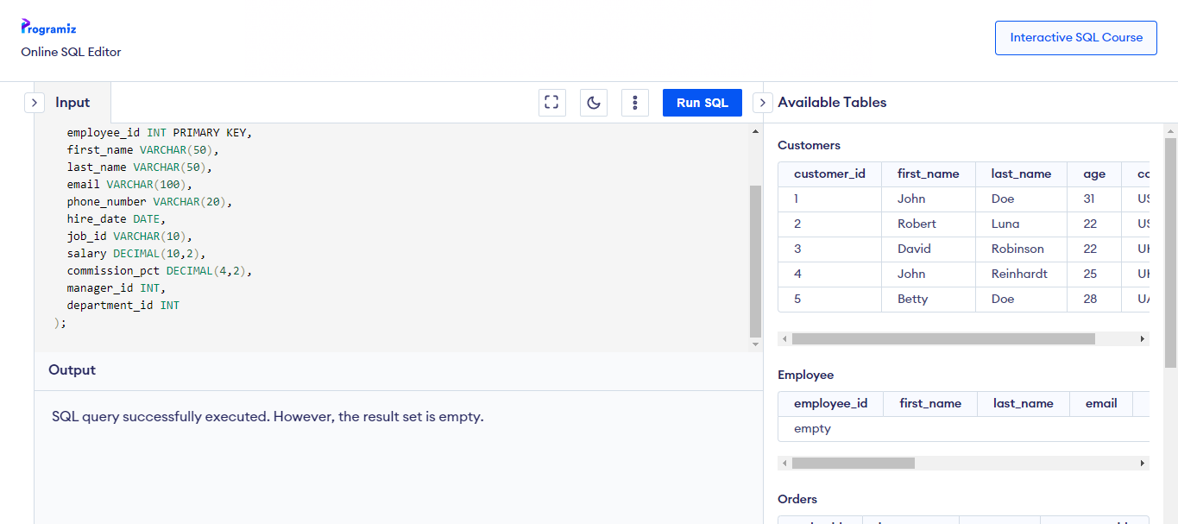

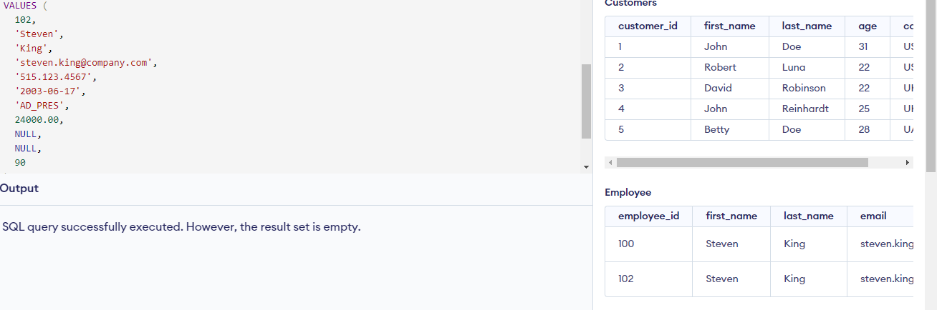

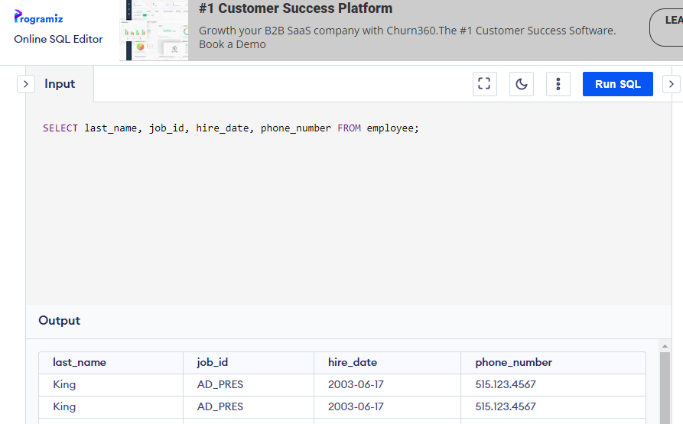

INSERT INTO employee (

employee_id,

first_name,

last_name,

email,

phone_number,

hire_date,

job_id,

salary,

commission_pct,

manager_id,

department_id

)

VALUES (

100,

'Steven',

'King',

'steven.king@company.com',

'515.123.4567',

'2003-06-17',

'AD_PRES',

24000.00,

NULL,

NULL,

90

);

(

101,

'john',

'smith',

'john.smith98@gmail.com.com',

'515.123.4578',

'2006-06-16',

'AD_PRES',

28000.00,

NULL,

NULL,

92

);